**Challenge1**

**Index.html**

<!DOCTYPE html>

<html lang="en">

<head>

    <meta charset="UTF-8">

    <meta http-equiv="X-UA-Compatible" content="IE=edge">

    <meta name="viewport" content="width=device-width, initial-scale=1.0">

    <title>ES6 variable life cycles</title>

</head>

<body>

    <script src="challenge1.js"></script>

</body>

</html>

**Challenge1.js**

'use strict';

var numbers1=[23,87,110,11,20,5,34];

var numbers2=[11,21,31];

const onlyOddNumbers= function(arr){

    var oddNumbers=[];

    var EVEN_NUMBERS_QUANTITY=0;

    const LEN= arr.length;

    for(let i=0;i<LEN;i++){

        arr[i]%2 ?oddNumbers.push(arr[i]) : EVEN_NUMBERS_QUANTITY++;

    }

    if(EVEN_NUMBERS_QUANTITY === 0){

        let info="Array contains only odd numbers";

        console.log(info);

    }

    else{

        let info ="There are "+ EVEN_NUMBERS_QUANTITY+ " even numbers";

        console.log(info);

    }

    return{

        oddNumbers: oddNumbers,

        EVEN_NUMBERS_QUANTITY: EVEN_NUMBERS_QUANTITY

    };

};

console.log(onlyOddNumbers(numbers1));

console.log(onlyOddNumbers(numbers2));

**Result**

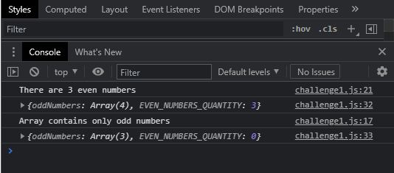

**Challenge2**

**Challenge2.html**

<html>

<head>

  <title>ES6</title>

  <link rel="icon" type="image/png" href="favicon.png" />

  <link rel="stylesheet" href="https://maxcdn.bootstrapcdn.com/bootstrap/4.0.0/css/bootstrap.min.css" integrity="sha384-Gn5384xqQ1aoWXA+058RXPxPg6fy4IWvTNh0E263XmFcJlSAwiGgFAW/dAiS6JXm"

    crossorigin="anonymous">

</head>

<body>

  <br />

  <ul class="nav nav-tabs">

    <li class="nav-item">

      <a class="nav-link active" href="#">Main</a>

    </li>

    <li class="nav-item">

      <a class="nav-link" href="#">Contacts</a>

    </li>

    <li class="nav-item">

      <a class="nav-link" href="#">Register</a>

    </li>

    <li class="nav-item">

      <a class="nav-link" href="#">Login</a>

    </li>

  </ul>

  <script src="challenge2.js"></script>

</body>

</html>

**Challenge2.js**

const menuItems = document.querySelectorAll(".nav-link");

const LEN = menuItems.length;

for (let i = 0; i < LEN; i++) {

  const menuItem = menuItems[i];

  menuItem.onclick = function() {

    for (let j = 0; j < LEN; j++) {

      menuItems[j].classList.remove("active");

    }

    // for (let j = 0; j < LEN; j++) {

    //     console.log(menuItems[j].classList);

    //   }

    menuItem.classList.add("active");

    console.log(menuItem.innerHTML);

  };

}

**Result**

